
Company
Logotype

Cone Beam Computed Tomography- Report



Porur Dental X-rays & CBCT

Patient Name : Mrs. Maheshwari | Date of Report : 19.07.2024
Age/ Gender : 40 years/ Female | Region of Interest : CBCT Sectional Mandible
Referring doctor: Dr. Lakshmi | Indication : Assessment of 46
Clinical Notes: Nil
PATIENT INFORMATION

CBCT- Sectional Mandible provided
CBCT – IMAGE DETAILS

RADIOGRAPHIC INTERPRETATION

- In relation to 46, hyperdense restorative material involving the crown and pulp chamber is evident.
- In relation to the distal root of 46, presence of a diffuse hypodense line of discontinuity running from the furcation region to the distal pulp canal at the level of 4.62 mm from the alveolar ridge. Additionally, presence of another hypodense fracture line at the apical third of the distal root
- presence of a diffuse hypodensity involving the furcation region is evident.
- The alveolar bone in relation to 46 is present with normal trabecular pattern.

RADIOGRAPHIC IMPRESSION

- Fractured distal root: 46

Kindly correlate with clinical findings


IMAGES FOR REFERENCE

RECONSTRUCTED PANORAMIC VIEW
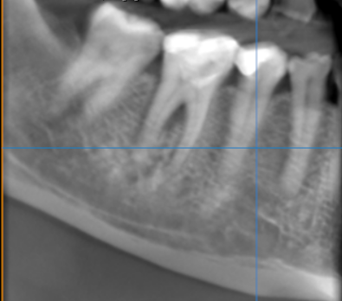

3-DIMENSIONAL VIEW
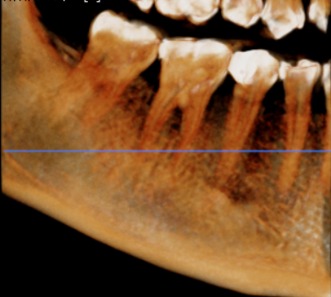

CROSS SECTIONAL VIEW
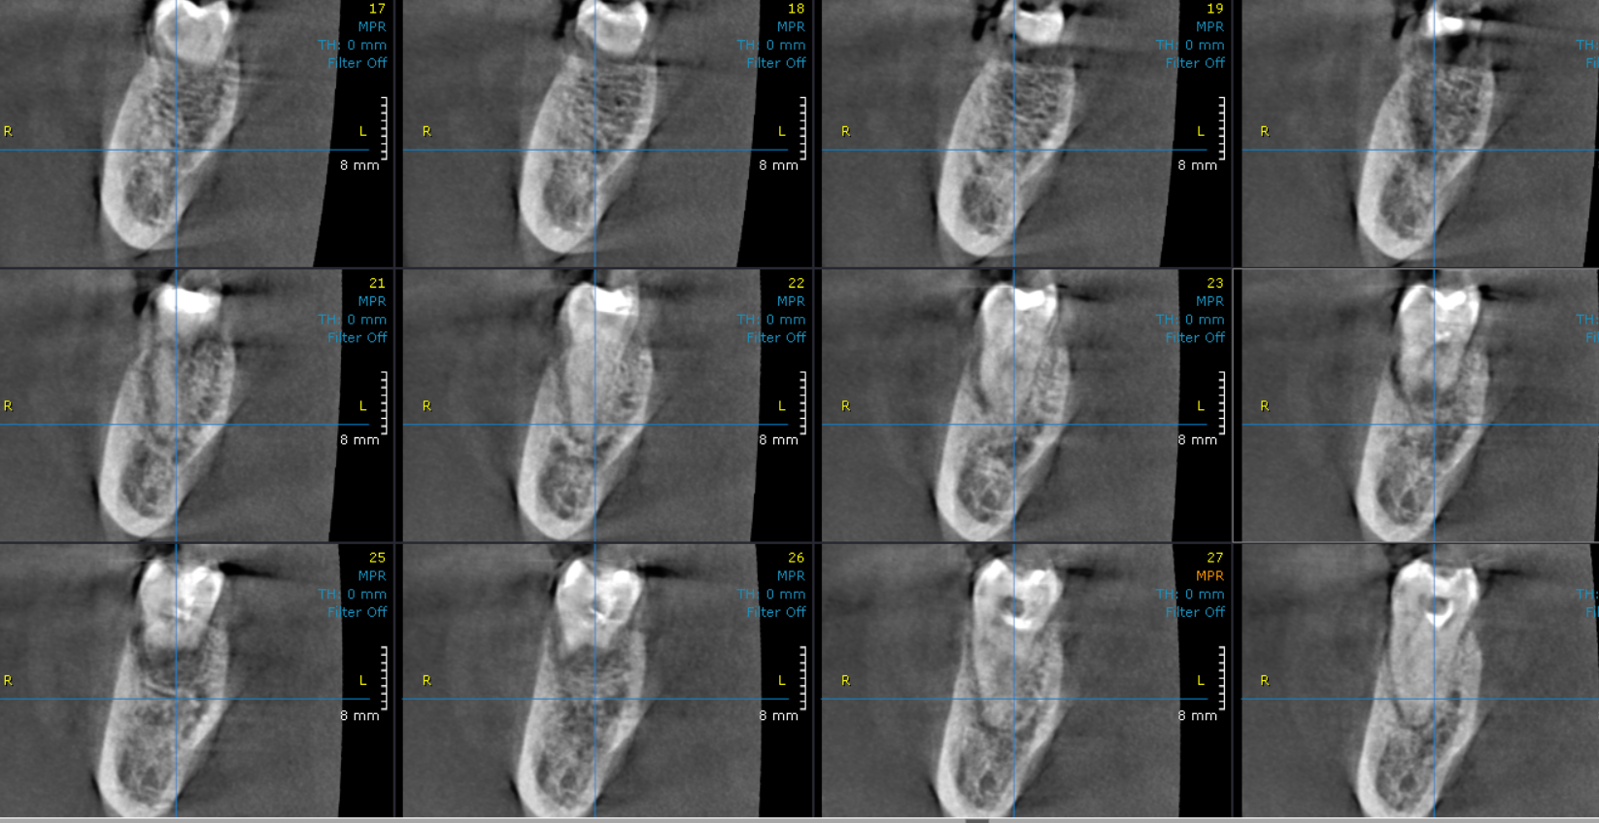

SAGITTAL VIEW
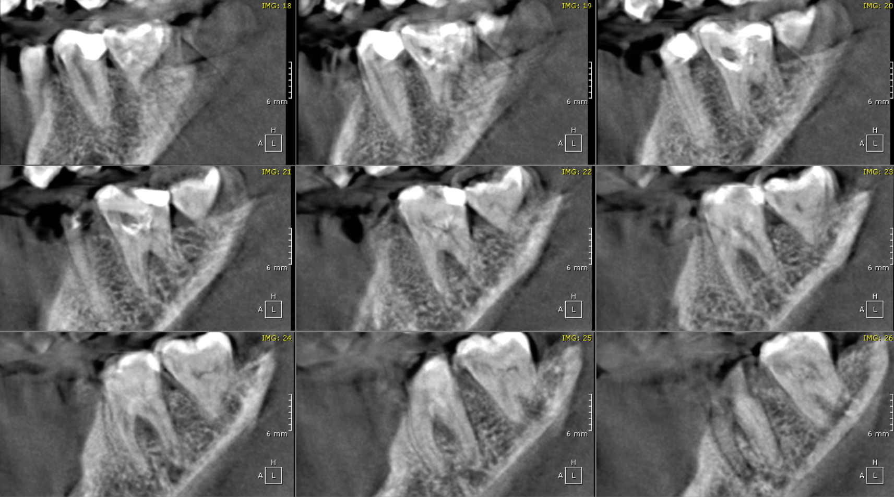

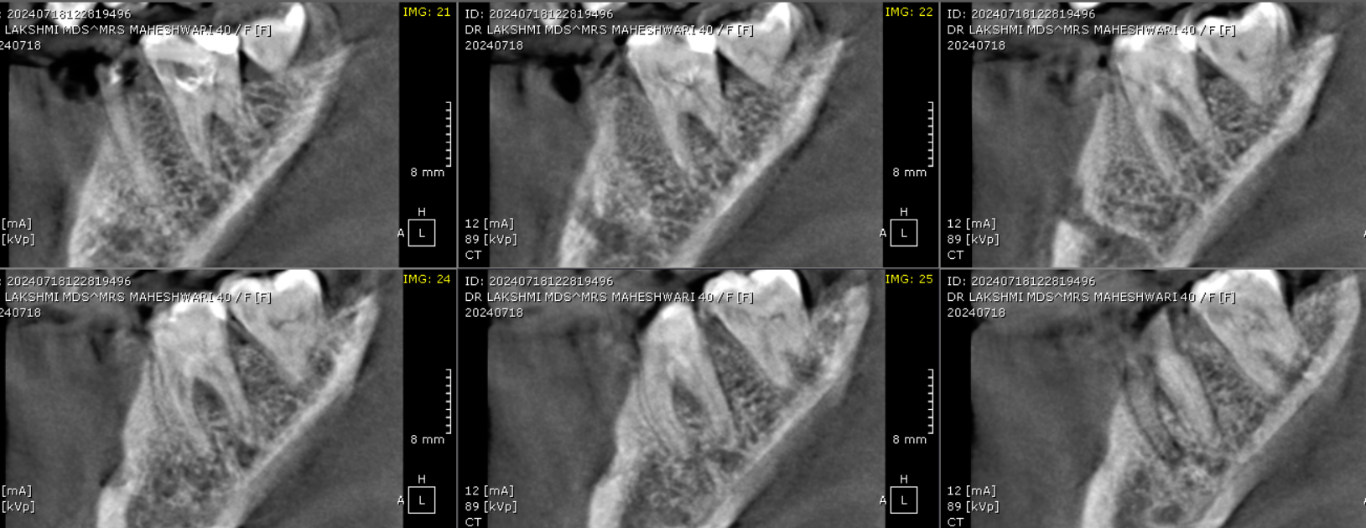

SAGITTAL VIEW

**** End of report ****

